
ISSN: 0067-2904
A New Chromogenic Reagent for Determination of Copper (II) in Water Samples Using Flow injection-Technique.

Mouayed Q. Al-Abachi¹, Sadeem Subhi Abed^{*1}, Nada Ali Al-Najjar²
¹Department of Chemistry, College of Science, University of Baghdad, Baghdad, Iraq
²Department of Chemistry, College of Science for Women, University of Baghdad, Baghdad, Iraq

Abstract
A new flow injection spectrophotometric method is described for the determination of copper ion Cu(II) in water samples (tap water and river water).The proposed method based on the formation of red complex [Cu(L)₂(NO₃)₂] which has a maximum absorption at λ_{max}=490 nm. Linear range for Cu (II) was from 5-70µg/mL with detection limit 2.55µg/mL. The effect of physical and chemical parameters were evaluated .The proposed method was applied successfully for determination of copper (II) in the tap and river water. [Cu(L)₂(NO₃)₂] complex was prepared in a (2:1) mole ratio as ( reagent: copper (II)).The analytical reagent formed by reaction of thymol with 4-aminoantipyrine at room temperature. The metal complex was characterized by IR, UV-Visible spectra. The metal percentage, electrical conductivity and magnetic properties of the formed complex confirmed that this chromogenic reagent was coordinated with copper (II) metal ion through oxygen and nitrogen atoms of the phenol and amine group as a bidentate ligand with octahedral geometry.
Key words: Copper ion (II), Flow- injection technique, New chromogenic reagent, Water samples.

كاشف لوني جديد لتقدير النحاس الثنائي في نماذج المياه باستخدام تقنية الحقن الجرياني

مؤيد قاسم العبايجي¹، سديم صبحي عبد^{1*}، ندى علي النجار²
¹قسم الكيمياء، كلية العلوم ، جامعة بغداد، بغداد، العراق
²قسم الكيمياء، كلية العلوم للبنات، جامعة بغداد، بغداد، العراق

الخلاصة
يتضمن البحث وصف طريقة الحقن الجرياني الطيفي لتقدير أيون النحاس الثنائي في نماذج المياه ( ماء الحنفية وماء النهر) .تعتمد الطريقة المقترحة على تكوين معقد أحمر اللون [Cu(L)₂(NO₃)₂] الذي أعطى أعلى أمتصاص عند الطول الموجي 490 نانومتر وكان المدى الخطي للنحاس (70-5) (II) مايكروغرام/ مل مع حد كشف مقداره 2.55 مايكروغرام / مل . كما تم دراسة تأثير الظروف الكيميائية والفيزيائية وطبقت الطريقة بنجاح لتقدير النحاس في ماء الحنفية وماء النهر. حضر معقد النحاس[Cu(L)₂(NO₃)₂] من خلال تفاعل النحاس الثنائي مع الكاشف بنسبة مولية (2:1) ( كاشف : النحاس الثنائي) . وقد تم تحضير الكاشف التحليلي من خلال تفاعل الثايمول مع4-امينو انتي بايرين .شخص تركيب المعقد باطياف الاشعة تحت الحمراء والاشعة فوق البنفسجية- المرئية وتم دراسة النسبة المئوية للفلز باستخدام تقنية الامتصاص الذري وقياسات التوصيلية والصفات المغناطيسيه في درجة حرارة الغرفة. بينت نتائج التحاليل المذكورة بأن الكاشف يسلك سلوك ثنائي السن ويتناسق مع الايون الفلزي من خلال ذرتي النتروجين والأوكسجين لمجموعة الفينول والأمين في الشكل ثماني السطوح.

Introduction
Copper is essential for all plants and animals [1]. It is an essential constituent of about thirty enzymes and glycoproteins and required for the synthesis of hemoglobin and for some biological processes. A deficiency of copper causes diseases such as anemia [2]. Though Copper was an essential element it becomes hazardous when present in excess. Excess of copper causes jaundice and Wilson disease [3]. Excess of copper in water was not only harmful to human beings, but also interferes with the self-purification of bulk water and exerts an adverse effect on the microbiological treatment of waste water. Too much Copper in water has also been found to damage marine life. As a pollutant, copper is of particular concern because of its high degree of toxicity of aquatic organisms, because of that, determination of trace amounts of copper is becoming increasingly in environmental pollution [4,5]. A number of analytical techniques have been developed in recent years for the determination of copper (II) in different matrices, including spectrophotometry [6-8],Inductive coupled plasma –atomic emission spectrometry [9], and flow injection analysis [10,11].
The aim of the present work is the determination of Cu(II) in water samples based on the formation of red color complex between Cu(II) and a new prepared reagent of an organic coupling compound between thymol and 4-aminoantipyrine(4-AAP) in alkaline medium.
Experimental
Chemicals
Distilled water and analytical grade reagents were used throughout this work without further purification.
- A stock solution of Cu(II) nitrate 1000µg.mL⁻¹[261.58 µg.mL⁻¹ of Cu(II)] was prepared by dissolving 0.1g of an analar product (BDH, UK) in distilled water in a 100-mL volumetric flask Working solutions were prepared by appropriate dilution of the stock solution with distilled water.
- 4-Aminoantipyrine (4-AAP) 0.1 mol.L⁻¹ was prepared by dissolving the required amount(2.0324g) of 4-AAP (BDH, UK) in distilled water in a 100 mL volumetric flask. Working solutions were prepared by appropriate dilution of the stock solution with distilled water
- Thymol 0.1 mol. L⁻¹ was prepared by dissolving 1.5022g of thymol (BDH, UK) in distilled water in a 100-mL volumetric flask.
- Ammonium hydroxide 1 mol. L⁻¹ was prepared by diluting 16.9 mL of 11.8 M of concentrated NH₄OH(25%) with distilled water in 100 mL volumetric flask.
Working solutions were prepared by appropriate dilution of the stock solution with distilled water.
Apparatus
Characterization of Cu(II) metal complex was achieved by using the following measurements:-
- Melting point of compound was measured using (Barloworld Scientific. LTD., United kingdom )) apparatus.
- I.R spectra of the prepared Cu(II) metal complex was recorded on
Shimadzu, FT-IR prestige-21 (Japan).
- Electronic spectra of the compound in (UV-Visible) was recorded on Shimadzu-UV-160A UV-Vis Spectrophotometer (Japan)at Ibn Sina Center using 1 cm quartz cell.
- The metal content of the complex was determined by atomic absorption technique using GBC 933 Plus Atomic Absorption Spectrophotometer (Japan).
- Electrical Conductivity measurements of complex of metal complex (ca10⁻³M) was made at room temperature using Lassco Digital Conductivity Meter(United Kingdom).
- Absorbance measurements were carried out on a Shimadzu UV-Visible-260 digital double-beam recording spectrophotometer (Tokyo-Japan) using 1-cm quartz flow cell with 50 μl internal volume and 1 cm bath length .
- A peristaltic pump (Ismatec, Labortechnik-Analytic, CH-8152, Glatbrugg-Zurich, Switzerland, six channels) was used to transport the reagents solutions. Flexible vinyl tubing of 0.5 mm internal diameter was used for the peristaltic pump.
- Injection valve (Rheodyne, Altex 210, Supelco-USA) was employed to provide appropriate injection volumes of standard solutions and samples.
- Reaction coil (RC) was of Teflon with internal diameter of 0.5 mm.
Procedures
Depending on the flow diagram manifold shown in Figure-1, a sample loop of injection valve loaded with copper sample in the range of 1-96 μg.mL⁻¹ were prepared from the working solution of 104 μg.mL⁻¹ of Cu(II) (2×10⁻³M) with volume (150 μL).The carrier stream was 4-AAP(9×10⁻³ mol. L⁻¹) at flow rate of 0.5 mL.min⁻¹ ,the latter passed through injection valve to load with a mixture of 5x10⁻³M Thymol in (0.1 M) NH₄OH at T-link with a flow rate of 0.5 mL min⁻¹. The resulting absorbance of the red product was measured at 490 nm and a calibration graph was constructed. Optimizations of conditions were carried out on 30 μg.mL⁻¹ of Cu(II).

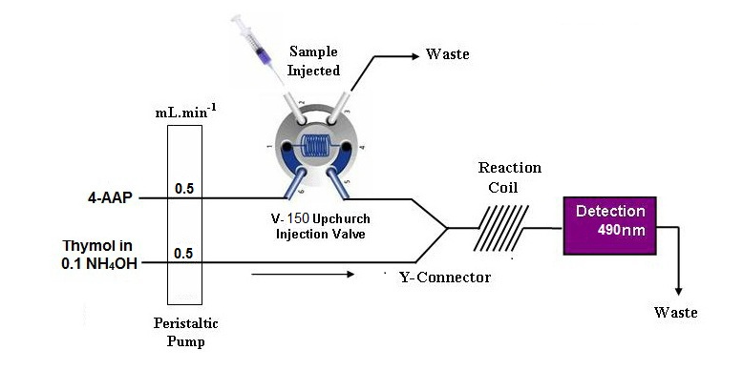
Figure 1- Flow system for determination of Cu(II).

Results and discussion
Characterization of the complex formed
The complex was prepared as organic coupling between thymol and 4-AAP in alkaline medium [12], followed by addition of the copper (II) nitrate in a mole ratio (2:1) (organic coupling: metal) with moderate yield (41 %), according to equation below:

The complex was characterized by spectral data .It was found to be stable and red color with a maximum absorption at 490 nm. The complex is soluble in water, methanol and dimethyl- sulphoxide with melting point (197ºC). The experimental values of percentage metal in the complex was (6.88%) in close agreement with the calculated value Table-1.This corroborated the proposed formula mass for the complex consequently, the molar conductance of the copper (II) complex was measured in ethanol and the value obtained as shown in Table-2 was (18)Ω⁻¹.cm².mol⁻¹ indicating the covalent nature[13].The infrared spectrum of this complex Figure-2 showed the absence of bands at (3433,3329) cm⁻¹ and ( 3232) cm⁻¹ corresponding to primary amine and hydroxyl group in the thymol and 4-AAP respectively. This indicated deprotonation of these groups and coordination to the metal ion through nitrogen and oxygen atoms of amine and hydroxyl groups respectively.
The υ(C= O) band in 4-AAP at 1647 cm⁻¹was still remained in the metal(II) complex due to un-coordination of the carbonyl oxygen atom to the metal (II) ion[14]. The vibration modes of NO₃⁻¹ group in this complex exhibited three bands as following 1483, 1267 and 1013 cm⁻¹[15]. Additional bands were observed in the spectrum of Cu(II) complex at (350-250)cm⁻¹ ,418 cm⁻¹ and 543 cm⁻¹ were attributed to υ(M-O) of the ONO₂ group , (M-N) and(C-O) group respectively [15]. The electronic spectrum of this complex in Figure-3 and Figure-4 consists of a high intensity band appears in the visible region at 20408cm⁻¹(490nm).This band is attributed to intra ligand π→π* transition Table-2.
It is lies at slightly lower energy compared with that of the original free reactants ( thymol and 4-AAP). Bands related to n→π* which may be located at the same region are masked by such extension .Complexation with metal ion was confirmed by the appearance of new bands in the visible regions which were assigned mainly to d-d transitions. The electronic spectrum of Cu(II) complex exhibited two absorption bands as shown in Figure -4 which appeared at (14430 cm⁻¹ ,693 nm) and (15479 cm⁻¹,648 nm). These bands were assigned to the transitions 2B1g→ 2B2g(υ2) and 2B1g→2Eg (υ3) respectively which is referred to Jahan-Teller distortion of octahedral Cu(II) complexes[15]. Based on the obtained analytical data and I.R spectrum, the suggested structure is illustrated in scheme-1 as follows:

Scheme 1- The suggested structure of Cu(L)₂(NO₃)₂ complex

Table 1-Physical properties, main characteristic vibration frequencies, electronic spectra and molar conductance of complex.
Comp.  Molecular formula | color | Mp.  ºC | Yield % | M% found (calculated) | Main characteristic vibration frequencies(cm⁻¹)
 |  |  |  |  | υ C=O | υ M-ONO₂ | υ M-N | υ M-OH
Cu(II) complex  Cu(L)₂(NO₃)₂ | red | 197 | 67.77 | 6.88  (7.19) | 1647 | 350-250 | 418 | 543

Table 2- Electronic spectrum and molar conductance of Cu(II) complex.
Symbol of compound | Band position (Cm⁻¹) | Assignments | Conductivity  cm².S.  mol⁻¹
Cu(II) complex  Cu(L)₂(NO₃)₂ | υ ₁20408  υ₂14430  υ₃15479 | π→π*  ²B₁g→²B₂g ²B₁g→²Eg | 18

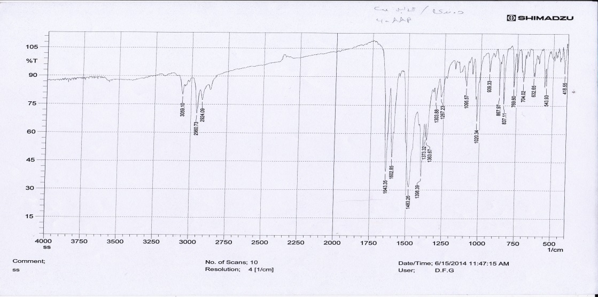
Figure 2- Infrared spectrum of Cu (L)₂ (NO₃)₂ complex.

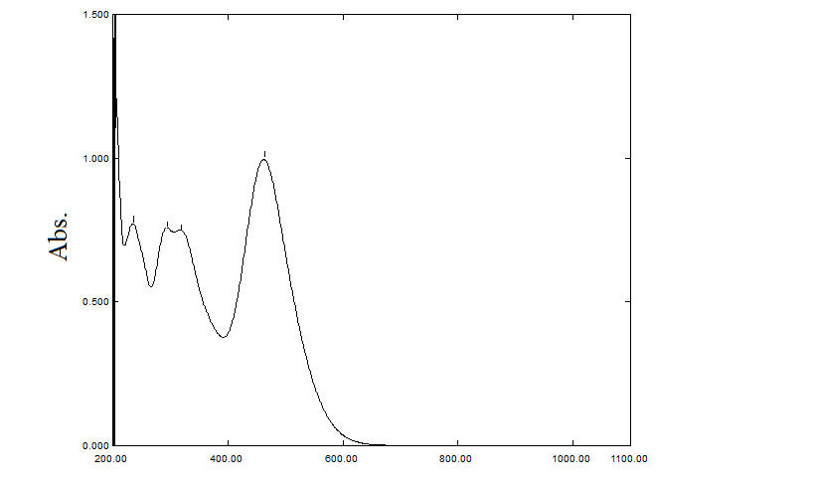
Figure 3- Electronic spectrum of Cu (L)₂ (NO₃)₂ complex
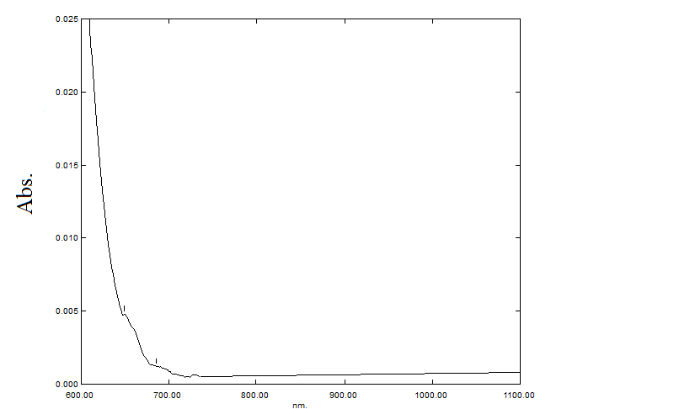
Figure 4- Electronic spectrum (d-d transition) of Cu (L)₂ (NO₃)₂ complex

The manifold used for the determination of copper was designed to provide different reaction conditions for magnifying the absorbance signal generated by the reaction of copper with mixture of 4-AAP and thymol in ammonium hydroxide medium. Maximum absorbance intensity was obtained when the sample (copper) was injected into a stream of 4-AAP and then mixed with mixture of thymol reagent and ammonium hydroxide as given in (Figure-1). The influences of different chemical and physical FIA parameters on the absorbance intensity of the colored product were optimized as follows:
Optimization of chemical parameters
The effect of various concentrations of 4- AAP (1×10⁻³– 12×10⁻³M) was studied for the formation of Cu(II) complexes with thymol(5×10⁻³M) in the presence of ammonium hydroxide(0.1M), 9×10⁻³M of 4-AAP seems to be optimum concentration as shown in Figure-5.

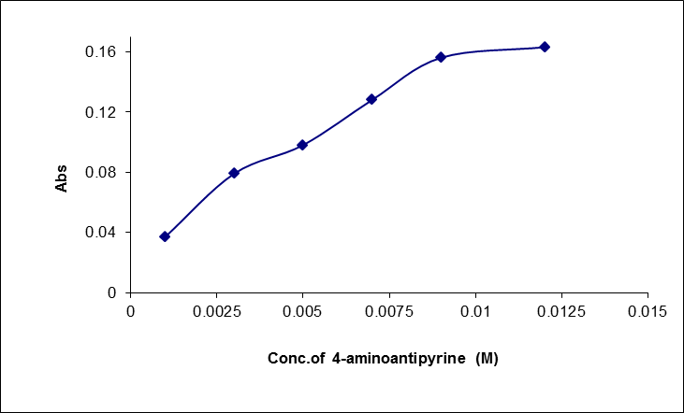
Figure 5- Effect of the concentration of 4-AAP.

At optimum concentration of 4-AAP (9×10⁻³M), the effects of various concentrations of thymol was investigated. A concentration of 5×10⁻³M thymol in the presence of ammonium hydroxide, gave the highest absorbance and was chosen for further experiments as shown in Figure- 6. Also the effect of different concentrations of ammonium hydroxide was studied and 0.1M was found to be the optimum for the reaction as shown in Figure-7.

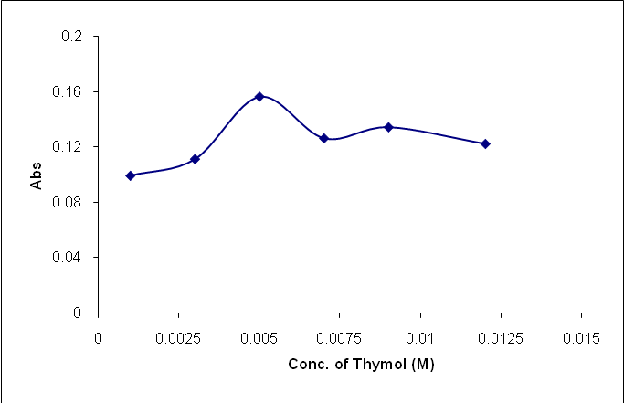
Figure 6- Effect of the concentration of thymol.

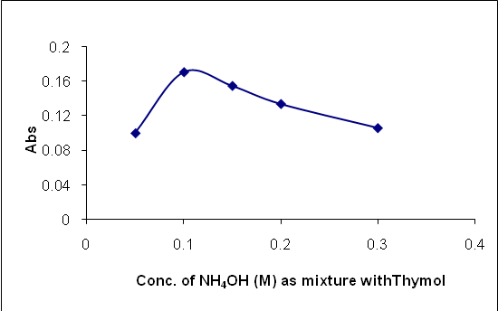

Figure 7- Effect of the concentration of ammonium hydroxide.

Optimization of manifold parameters
The variables studied under the optimized reagent concentrations were the flow rate, the injection sample volume and the reaction coil length. The effect of total flow rate on the sensitivity of the colored reaction product was investigated in the range of 0.5-2.5 mLmin⁻¹. The result obtained showed that a total flow rate of 1mL min⁻¹, (0.5 mL min⁻¹ in each line) gave the highest absorbance as shown in Figure- 8, and was used in all subsequent experiments.

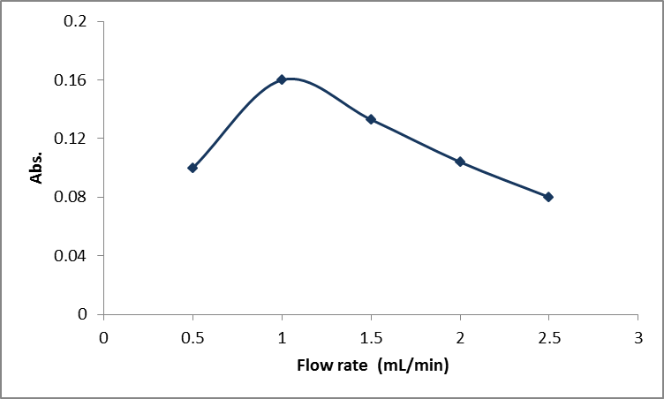
Figure 8- Effect of the total flow rate.

The volume of the injection sample was varied between 50-200 μL using different length of sample loop. The results obtained showed in Figure-9 that injected sample of 150 μL gave the best absorbance.

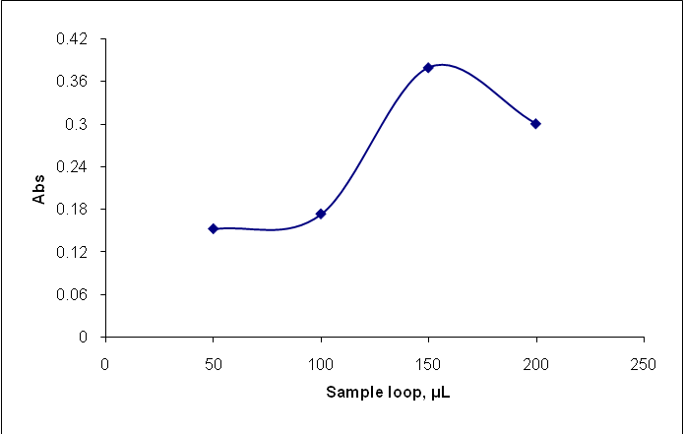
Figure 9- Effect of the injection loop.

The coil length is an essential parameter that affects on the sensitivity of the colored reaction product and was investigated in the range of 25-250 cm. the results obtained showed that a coil length of 100 cm gave the highest absorbance as shown in Figure-10 and was used in all subsequent experiments.

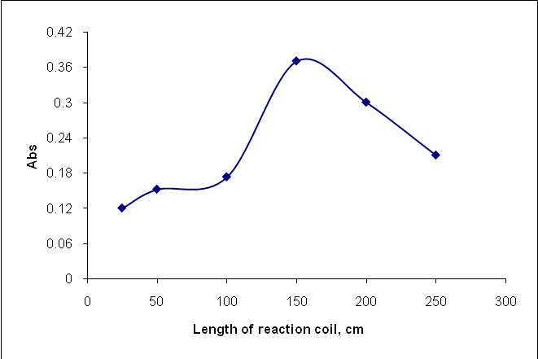
Figure 10- Effect of the length of the reaction coil.

Calibration curve and the statistical data
Under optimum chemical and physical conditions described in the previous sections , the calibration curve for the determination of copper shown in Figure-11 obeys Beer's law between (5–70 μg.mL⁻¹) Cu(II) with correlation coefficient 0.9933 and the sampling rate was 45 sample / hour. The calibration curve can be represented by a linear regression equation Y = 0.0122 [X] +0.0059 Where [X] refer to the concentration of copper (II). Table-3 tabulates the average, standard deviation and the repeatability of the proposed method for determination of copper (II) at the confidence limit at 95%.

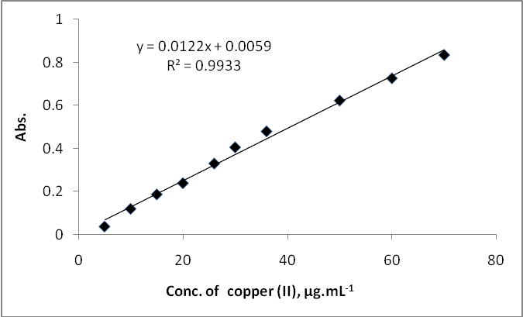
Figure 11- The variation of absorbance versus the concentration of copper (II)

Analysis of copper(II) in water samples
The suggested methods were applied to the quantitative determination of copper in water samples (tap and river water). The results gave a good accuracy and precision as shown in Table- 4.

Table3- Analytical characteristics of the procedure developed for the determination of Copper (II).

Parameter
Regression equation | y=0.0122x+0.0059
Linear range  (μg mL⁻¹ ) | 5-70
Correlation coefficient | 0.9933
LOD(s/n=3) μg mL⁻¹ | 2.55
LOQ(s/n=3) μg mL⁻¹ | 3.60
Reproducibility, % | <0.87
Average of recovery,% | 99.85
Sandellۥs Sensitivity (µg.cm⁻²) | 0.157
Sampling frequency  (per hour ) | 45

Table 4- Application of the proposed for the determination of copper (II)
Water samples | Conc. of copper(II)  (μg.mL⁻¹) |  |  | E%* | Rec.%* | RSD%
Water samples | present |  | Found | E%* | Rec.%* | RSD%
River water | 5  10  20  30 | 5.11  9.89  20.09  29.87 |  | +2.20  -1.10  +0.45  -0.43 | 102.20  98.90  100.45  99.57 | 1.24  1.89  2.21  0.98
Tap water | 5  10  20  30 | 4.95  10.20  19.97  29.91 |  | -0.01  +2.0  -0.15  -0.30 | 99.99  102.0  99.85  99.70 | 2.13  1.05  1.76  1.23

Conclusion
The results obtained confirm that the proposed method is simple, economical with reasonable precision and accuracy for the determination of copper(II). The optical parameters and statistical comparison justify this method for application in routine metal estimation in water samples. Also, the procedure does not involve any critical reaction conditions or tedious sample preparation steps. So, the recommended method is well suited for the assay and evaluation of copper(II) in water samples and can also be considered as a general method for the quantification of copper(II). In comparison of the other methods as shown in Table-5 with the proposed FIA procedure, the latter is more convenient and simpler method than the former methods because of its wider linear range of the calibration graph and speed (sample through-put of 45 injection h⁻¹).

Table 5- Comparison of some analytical methods for determination of copper(II) with the proposed method.
Reagent used | Calibration range | ƛ_{max} | Notes | Ref.
2-(6-Bromo-2-benzothiazolyl azo)-4-chloro phenol | 0.05–1.2 μg/mL | 636 nm | Reaction conditions need to control pH | 8
4-  (6-bromo-2-benzothiazolylazo) pyrogallol | 0.01-7.0 μg/mL | 570nm | Reaction conditions need to control pH | 10
oxalic acid bis(cyclohexylidene hydrazide) (cuprizone) | 0.06–4 μg/mL | 590nm | Reaction conditions need to control pH | 11
4-AAP and thymol | 5-70 µg/mL | 490 nm | Simple automated flow injection method | This work

References
- Buffle , J. 1990. Complexation Reactions in Aquatic Systems—An Analytical Approach. First Edition. Ellis -Horwood Inc., Chichester, UK, pp:232.
- Gopala, K. D., Devanna, N. and Chandrasekhar B. 2011. Direct and derivative spectrophotometric determination of copper (II) in presence of micellar medium in beer, wine, biological materials and alloy samples using cinnamaldehyde4-hydroxybenzoylhydrazone (CMHBH). International Journal of Analytical and Bioanalytical Chemistry, 1(1): 19-24.
- Göksungur, Y., Uren, S. and Güvenç, U. 2005. Biosorption of cadmium and lead ions by ethanol treated waste baker's yeast biomass. Bioresource Technol., 96: 103-110.
- Trojanowicz, M. 2000. Flow Injection Analysis: Instrumentation and Application. First Edition. World Scientific Inc. , Singapore, pp:345.
- Shakir, I.M.A. and Turkie, N.S. 2013. Spectrophotometric-continuous flow injection analysis(S-CFIA) for the determination of cobalt(II) ion in river& alloy samples via the use of 10,10-dimethyl 9,9-diacridinium dinitrate salt-hydrogen peroxide in alkaline medium . Journal of Kerbala University, 11(3): 244-258.
- Ghazya, S.E., El-Shazlya, R.M., El-Shahawib, M.S., Al-Hazmia, G.A.A. and El-Asmya, A.A. 2006. Spectrophotometric determination of copper(II) in natural waters, vitamins and certified steel scrap samples using acetophenone-p-chlorophenylthiosemicarbazone. Journal of the Iranian Chemical Society, 3(2):140-150.
- Rekha, D., Suvardhan, K., Surshkumar, K., Reddyprasad, P., Jayaraj, B. and Chairnjeevi, P. 2007. Extractive spectrophotometric determination of copper(II) in water and alloy samples with 3-methoxy-4-hydroxybenzaldehyde-4-bromophenyl hydrazone (3,4-MHBBPH). J. Serb. Chem. Soc., 72 (3): 299–310.
- Jewad, A. A. R., Kadhim, K.H. and Al-Sharefy, A. N. 2005. Synthesis and spectrophotometric study of 2-(6-Bromo-2-benzothiazolylazo)-4-chloro phenol as an analytical reagent for determination of copper. National Journal of Chemistry, 19: 331-338.
- Ferreira, S.L.C., Dos Santos, H.C., Ferreira, J. R., Lopo de Araújo, N. M., Costa, A.C.S. and De Jesus D. S. 1998. Pre-concentration and determination of copper and zinc in natural water samples by ICP-AES after complexation and sorption on amberlite XAD-2. Braz.Chem.Soc., 9(6):525-530.
- Nasser, N.A., Taha, D.N. and Kahdim, K.H. 2013. A simple flow injection-spectrophotometric determination of copper (II) using 4-(6-bromo-2-benzothiazolylazo) pyrogallol as chromogenic agent. Journal of Babylon University/Pure and Applied Sciences, 21(7): 2544-2554.
- Rumori, P. and Cerdà, V. 2003. Reversed flow injection and sandwich sequential injection methods for the spectrophotometric determination of copper(II) with cuprizone. Analytica Chimica Acta, 486: 227–235.
- Al-Abachi, M.Q. and Al-Najjar, N.A. 2015. Flow injection spectrophotometric determination of thymol using 4-aminoantipyrine and copper (II) nitrate. Baghdad Science Journal, 12(2): 332-339.
- Silverstein, R. M., Bassler, C. G. and Morrill, T. C. 2005. Spectrometric Identification of Organic Compounds. Seventh Edition. John Wiley and Sons. Inc., New York, pp: (88-90,101).
- Nakamodo K. 1997. Infrared and Raman spectra of Inorganic and Coordination Compounds. Second Edition. John Wiley and Sons. Inc, New York. pp: 87-89.
- Figgis, B. 2000. Ligand Field Theory and Its Application. First Edition. John Wiley and Sons. Inc, New York. pp: (105,171-175,210-212).

